## SOFTWARE DEVELOPMENT LIFE CYCLE(SDLC):

It consists of the below phases,

1. Requirement Phase
2. Analysis Phase
3. Design phase
4. Coding Phase
5. Testing phase
6. Delivery and maintenance Phase.

**PIN:**Project initiation/intimation note:

It’s an email, will be prepared by the project manager where it contains the start date and end date of the project. The mail will be sent to the client and the high-level management.

PIN indicates the start of the project.

#### Requirement phase:

**Roles**: Business Analyst, PDA

Project Manager

* BA is responsible to collect all the requirements in a Requirement template document (RTD).
* Once all the requirements are collected in the requirement template then they will sign off the requirements,
* The signed off document is known as *SRS (Software/system requirement specification)* or *BRS (Business requirement specification)* or*FRS (Functional requirement specification)* or*BDD (Business design document)* or *BD (Business document).*
* Once the SRS document is baselined, the BA is responsible for POC (Proof of concept).
* During POC the BA is responsible to develop the prototype and it will be presented to the client.

**Prototype:** It's rough and rapidly developed sample Application; it doesn’t contain any of the actual functionalities. It simply describes how the project is going to be and how it is going to display. The main purpose of the prototype is to collect all the requirements properly and to understand all the requirements properly.

* Project Manager is responsible to monitor the phases and he will help both BA and EM to complete their activities properly.

Note: The outcome of requirement phase is SRS and Prototype

1. **Analysis Phase:**Analyzing the requirements.

Roles:High level Management Middle level Management Project Manager

BA

* All the above roles will assemble for a meeting and they will perform the below activities
  1. Feasibility Study
  2. Technology selection
  3. Resource plan
  4. Hardware & Software plan
     1. **Feasibility study**: Feasible means possible or not. The above roles will take each and every requirement in SRS document. Requirements will be analyzed and they will identify whether it is possible to develop or not, if it is possible to develop then they will identify how much time is needed for development, testing and delivering it to the client. If any requirement is not feasible to develop then they will inform it to the client.
     2. **Technology selection:** The list of technologies like Java, .net, MSSQL,Oracle, selenium etc. are required for the project development, testing and delivery to the client will be described here. Based on the technologies they will hire the resources.
     3. **Resource Plan:** The number of resources like developers, test engineers, database engineers are required for the project development and testing will be described here.
     4. **Hardware and software plan:** The amount of hardware’s like desktops, laptops, mobiles, printers etc... With related software's are required for the project will be described here.
* All the above will be documented in document called project plan. It will be sent to the client, for review.

#### Design Phase:

Roles: Architect/chief architect Business Analyst (BA) Project Manager

* Architect will review all the requirements of the SRS Document, while reviewing if any clarifications are needed on the requirements then BA is responsible to clear all the uncleared requirements.
* Once the Architect is clear on all the requirements then he will divide the requirements into multiple modules and sub modules.Group of related requirements is known as ‘*Module*’.
* Once all the modules are divided then he will provide the architectural diagram (flow diagram) of the entire project with the help of UML (unified modeling language)
* All the above will be documented in a document called Design document or SRS.

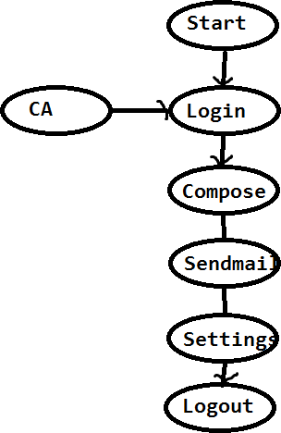

#### Coding phase:

Roles**:** Developing team

Testing team BA

Project Manager

* Once the modules are divided by architect they will be assigned to the developers as well as testing team.
* The developers are responsible to develop the source code for the modules. Once the source code is stable then they will *checkin* the source code into the *central repository*.
* The development lead will *checkout* the source code to his local system, then the development lead will build the source code and the build will be released to the testing team for testing.

**Central Repository:**

Repository means a storage folder. Central Repository means the folder which is commonly accessible to all the resources in the organization. It contains all the secure files.

Ex: SVN- Sub Version

VSS- Visual source safe

TFS- Team Foundation Server CVS- Concurrent Version system Perforce, Github

**Check in:**The process of uploading the files from the local system to central repository is known as *Check in* or *Commit*.

**Check out:**The process of downloading the files from the central repository to the local system is known as *Check out*.

**Build:**The process of converting the source code to executable code is known as *Build*.

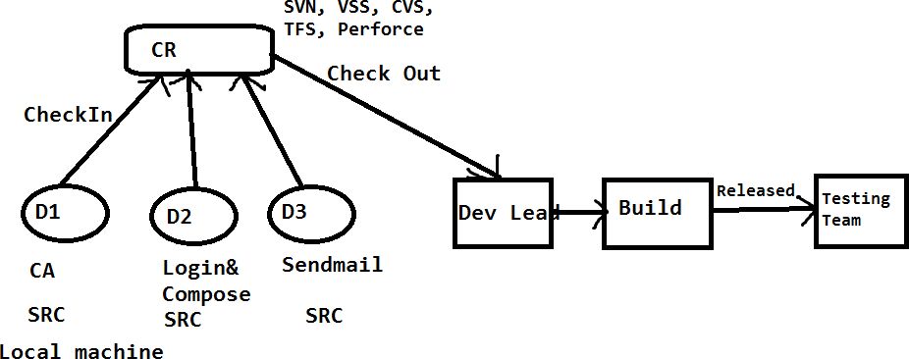

#### Testing Phase:

Roles:Test Engineers Dev team

Business Analyst (BA) Project Manager

* Once the SRS Document is base lined (Completed), it will be sent to both development team as well as testing team.
* Development Team is responsible to review the SRS document, understand it and develop the build.
* Testing team is also responsible to review the SRS Document. While reviewing,if any *unclear requirements* (Doubts) are identified those will be updated into the document called “*Review Report(RR)*”.
* The review report will be sent to the team lead where he will consolidate (Make one document) all the review reports to a single document called “*Consolidated review report*(CRR)”and it will be sent to the BA.
* BA is responsible to Review all the unclear requirements and he will provide the

clarifications, then the “*Updated Review report*(URR)” will be sent to the testing team

* The testing team will again Review the SRS document with clarifications.
* Once the testing team is very clear on all the requirements then they will take the test case template and write the test cases for all the requirements.
* The test cases documents will be sent to the BA. Where he will review it and he will provide the comments whether any new test cases are needed to be added.
* Based on BA comments the testing team will update the test cases.
* Once test cases are base lined (completed) it will be sent to the client for final review.
* Once the build is released to the testing team, they will execute all the test cases on the Build.
* While testing the build,if any Bugs are identified it will be reported (send) to the development team. Developer will fix it and send it back to the testing team for testing.
* Test Engineer will test that whether the bug is really fixed or not and at the same time he will check for other bugs.
* If identified it will be reported to the developer.
* The same process will be continued until the build is stable (Bug free or No Bugs).
* The stable build will be delivered to the client.

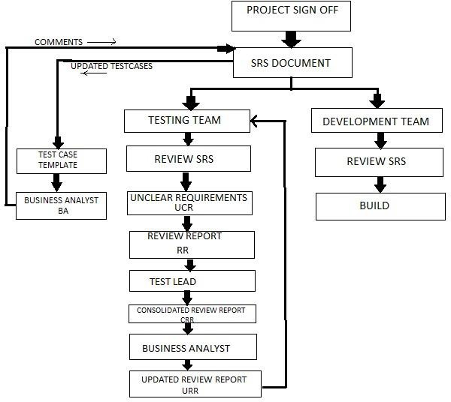

#### Delivery and Maintenance:

Roles:Test Engineers Dev team

Business Analyst (BA) Project Manager

Client

**Delivery:**Once the build is stable in test environment the testing team (TL) will send email to the project manager saying that the build is stable then the project manager will deliver the build to the client.

* The client will deploy the build in stage environment and perform testing.
* *Stage environmen*t is the common environment where both testing team and client’s team will test the application before it go live.It is also known as *pre-production environment.*
* Once the Build is stable in stage environment then the client will deploy the build in *live or production environment.*
* Once the build is successfully deployed in production/live environment then we can conclude that the project is successfully delivered to the client.

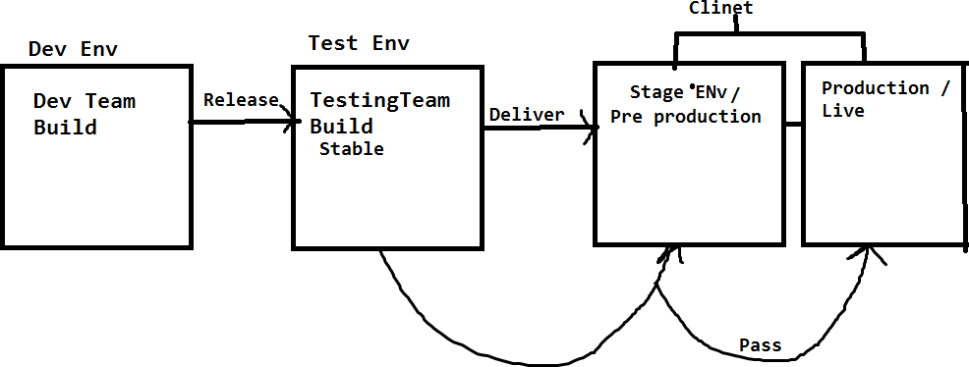

#### Maintenance:

*‘Live’* means where the client or endusers are using the application. Maintenance will be continued as long as application is on live.

MaintenancePhase TAT



Fixing the Bugs, CRs (Enhancement)

Turnaround time

Client

3 Bugs

3 CRs

BA/PM/TL

Company

12/24 Hours 3 Bugs – 3 days 3 CRS – 4 days

7 days

* Once the project is successfully delivered to the client and it is successfully deployed in live/production environment then the maintenance of project will be started.
* During the maintenance the company is responsible for two activities.

1. Fixing the Bugs.
2. Updating the enhancements/Change requests CRs.

* As long as project is on live, the maintenance of the project will be continued.
* As per the signoff (Agreement) initially the company will be providing free maintenance up to 3 to 5 years (it depends on the project signoff).
* Once the free maintenance period is completed the client will renew the maintenance agreement.
* Whenever the client is sending any bugs and CRS then, from the company someone (Developer, BA, Tester) has to send the acknowledgement email to the client within the TAT ( Turnaround time) agreed as per the agreement, it could be 12/24 hours.
* The mail contains the number of hours which we are going to take to fix and deliver the new build to the client.
* As long as project is on live the maintenance of the project will be continued